Interview: Mike Turian
Nate Heiss
If you walked up to me at a tournament and asked me for a reason why Magic is so great, I would answer, "the people". As far as Magic personalities go, Mike Turian has cemented himself in the hearts of the Magic community with his personality more than with his wild success story. Mike is more than a player, more than the Potato... he is just a great guy to hang out with. I spent a few minutes talking to him.
Nate: Mike, even though you have not had the stunning success of Finkel, Budde, or even Zvi...you are still considered one of the Pro Tours greatest assets. Why do you think that is?
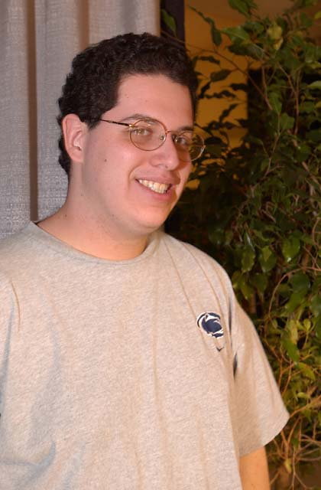
Mike: It is hard to evaluate... guys like Price, Humphries, and Pikula will be around forever even though they didn't win 17 Pro Tours in a row. Everyone just knows that their familiar face will be there, and those are the faces of the Pro Tour that makes the Pro Tour great. I have been qualified for every Pro Tour since the first Chicago and I have only skipped the Worlds in Brussels in all of that time. I think that people appreciate that, or at least I hope they do.
(You will remember Mike as having great finishes from the start, scoring a Top 32 at his first Pro Tour at Chicago... yes, the first PT-Chicago. Mike has been around the block a few times, and knows how to navigate the Tour. His best finishes to date are a Team PT win with Potato Nation at the first New York Team Pro Tour, a Top 8 at Worlds 2001 in Toronto, a Top 8 at the 2000 US National Championship and a recent win at Grand Prix-Montreal.)
Nate: You seem to be doing better these days. You had a slight slump after Randy Buehler left CMU to work for Wizards, but since Nationals 2000, you have been on something of a hot streak. Any reason why?
Mike: I decided that once I started playing more seriously, I should go all the way. I have really dedicated myself to the game, stepping up my Constructed performance. I think it rounded me out as a better player.
Nate: So what do you think is the greatest factor to your success?
Mike: I'M GOOOOOOOD!
Nate: GOOOOOOD!
Mike: Seriously though, when we started playing, we played a ton. You remember Nate... I would come home from school and play Magic. I would go out on the weekend and play Magic. Friends would come over and we would play Magic. Fourteen is the best age to start playing Magic; you just don't have any of the responsibilities that an adult has. That kind of dedication really pays off. For instance, when I go to a Prerelease, all of the goofing around I did makes it so I just KNOW what is good.
Nate: What is your favorite part of tournament Magic?
Mike: Easy... winning! I really enjoy having fun and hanging out. My absolute favorite thing is smashing friends in a tournament... especially Eugene Harvey! You know what I like the least? Getting smashed by friends in a tournament.
Nate: I have smashed you a few times in my day. Not very many, granted... but a few times at least.
Mike: Nope, never. Ha ha, I will admit that you made the right choice playing my Survival design at Pro Tour-Rome, while I stuck with a better deck, Academy, that wasn't suited to my strengths. Also, you did beat me around with a Royal Assassin, Icy Manipulator deck for a while, but besides that I can't remember ever losing to you in the seven years I have played. Of course, I happen to be very forgetful.
Nate: Right... like when I knocked you right out of Pro Tour-New York... you know, the one with the Wildfires and the Tolarian Academies all over. At any rate, we all have our significant moments in the game... what are the three most significant moments in your time playing Magic?
Mike: Well, do you remember that tournament at Legends where I had to play Evan?
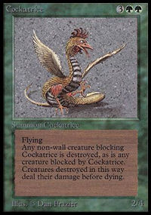
Nate: The one with the Cockatrice? (Legend's was a store where Mike and I used to play back in the day. Evan Davis was Mike's best friend at the time... he was one of the few people Mike taught Magic to, another being myself.)
Mike: Yeah. So I am swinging with this Cockatrice for the whole game, but we were both at some ridiculously high life totals. He had a Diamond Valley and I had an Ivory Tower. I was gaining life every turn, and he gained a ton off of a Giant Growthed, Forked, and Berserked creature that I sent farming (with Swords to Plowshares). We were up in the 50's. Anyhow, I was doing something on one turn and said, 'done' before I had attacked with my Cockatrice. Evan wouldn't let me take back the play. Sure enough, when time was called, I lost the match on life totals... I was short by two points... the amount that I could have dealt of I had attacked. Ever since then, I have realized that tournament play is for keeps. You have to playtest the same way a tournament is run. No take-backs, what-ifs, and so on. It taught me about higher standards in playtesting.
Nate: I totally agree. Some people turn playtesting into a discussion of hypothetical probabilities and circumstances. The only real way to playtest is to get to the heart of the matter and play like it's the real deal. So what is significant moment number two?
Mike: I would have to say that meeting Randy Buehler at the Dungeon (another gaming store) and splitting with him in the finals of a Black Lotus tournament was very significant. Since we couldn't simply split the Lotus in two, we had to exchange our contact information. Since Randy won the tournament, he agreed to sell it and then split the money with me. When I called him up to get my split money, we started talking Magic. Along the way I agreed to test the qualifier format for Chicago (Mirage Block Constructed) with him even though I was already qualified. Of course, he eventually qualified with Sandsapoise and Randy, Lauer, Silberman, and I all went up to GP-Toronto together where Team CMU was formed.
Nate: I may have missed out on the initial fun at Toronto, but I do know that when you hooked up with Randy and mentioned that you were going to CMU next fall, it was like fate knocking. Why did you agree to test a PTQ format that you were already qualified for?
Mike: Magic is about friends, and I rarely pass up the opportunity to make new friends. Evan and I were going to the qualifiers anyhow, so I just wanted to play Magic.
Nate: So what is the third most significant moment?
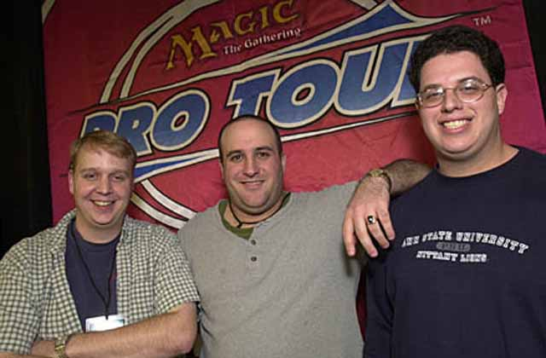
Scott Johns, Gary Wise and Mike Turian
Mike: Winning the Pro Tour, of course. You really get a lot of respect for that, and that was really what I had been looking for since I first started on the Tour. It is like a breath of fresh air, and I am glad I could share it with two great friends, Gary and Scott.
Nate: What is the most important advice that you can give our readers?
Mike: Have the right attitude from the start or don't bother to shuffle up.
Nate: Since you are the most respected Limited player in the world, what advice can you give all the PTQ goers of Magic?
Mike: Use the good cards, cut the bad ones.
Nate: Answered in true potato fashion... I have one last question for you, Mike.
Mike: Shoot.
Nate: You have been known to drive as much as three or four hours to take unqualified people to Pro Tour Qualifiers even though you are prohibited from playing in them due to your qualified status. Why do you exert such effort to help your friends qualify?
Mike: Well, there are a few reasons... Eugene just asked me the same question last night, so I actually have an answer prepared... (Mike then thinks for about five minutes). I would have to say that when people play Magic, they do it for different reasons. Some people play for fun, others play for money. When I play Magic, I do it for respect. Whenever I do well, people respect me more for that. It is not so much the fame or the money, even though they don't hurt. But let me ask you, what good is respect if you don't cash in sometimes? Who cares who Mike Turian is if he doesn't show up to tournaments? If I didn't go to these qualifiers, I would only be able to play in Pro Tours and Prereleases. I would be some guy that no one ever sees. I want to go to the qualifiers and hang out with my friends, root for my teammates, and see everyone. I really enjoy it when people come up to me and ask me the right ways to build their sealed decks... they have respect for my opinion. For me, that is what the game is all about. I think I might have explained it better to Eugene last night.
Nate: No, it makes a lot of sense. You go to see your friends. I have always held that Magic is more about the players than anything else.
Mike: I also go to test and stuff, I get to see what everyone is thinking and play with them a little. It is good to strengthen ties between players. Do you think Alex Borteh would have conceded to me at Worlds if I were just some Pittsburgh player who he had seen once or twice at a Prerelease? Do you think I would be able to talk about strategy and test with all the Ohio guys if I never went there? Qualified people show up to qualifiers all the time... the lifeblood of Magic is at the qualifiers, not at the Pro Tours.
Nate: It is good to hear you say that. Well, that pretty much wraps up our interview. Thanks for your time... oh, by the way can I have a ride to Columbus next week?
(Note: This entire interview was actually conducted in the wee hours of the morning in Mike's car on the way to Columbus for a PTQ. He was driving.)

